ZMG07

System: EBS
Main Program: ZMPUR31A_INV_REL_REPORT
Package: ZEBS_GT_PR
Selection screen:
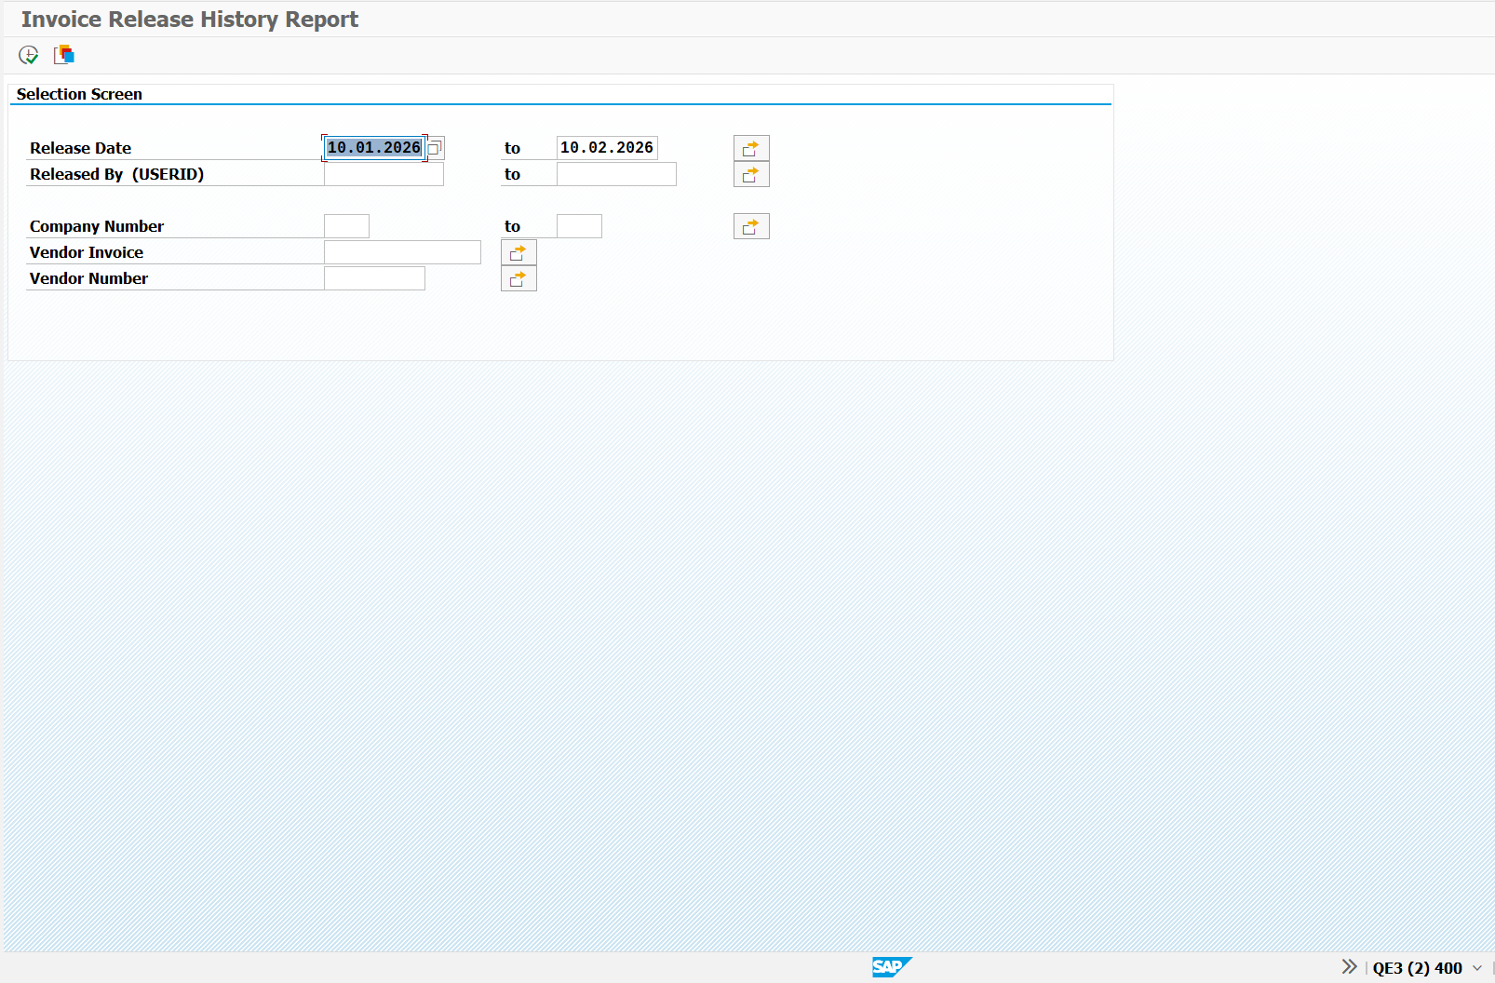

Corresponding selection screen parameters:
SELECT-OPTIONS: s_aedat FOR sy-datum. " Change Date
SELECT-OPTIONS: s_uname FOR trdyse01cm-username. " Changed By
SELECTION-SCREEN SKIP.
SELECT-OPTIONS: s_bukrs FOR bkpf-bukrs. " Company Code
SELECT-OPTIONS: s_xblnr FOR bkpf-xblnr NO INTERVALS. " Vendor Invoice
SELECT-OPTIONS: s_lifnr FOR lfa1-lifnr NO INTERVALS. " Vendor Number
Tables & Fields:
- CDHDR (Change document header)
A) objectclas (Change doc. object)
B) objected (Object value)
C) changenr (Document Number)
D) username (User)
E) udate (Date)
- CDPOS (Change document items)
A) objectclas
B) objected
C) changenr
D) tabname (Table Name)
E) tabkey (Table Key)
F) fname (Field Name)
G) chngind (Change indicator)
- BSEG (Accounting Document Segment)
A) bukrs (company code)
B) belnr (Document Number)
C) gjahr (Fiscal Year)
D) buzei (Item)
E) koart (Account Type)
F) wrbtr (Amount)
G) lifnr (Vendor number)
- BKPF (Accounting Document Header)
A) bukrs
B) belnr
C) gjahr
D) budat (Posting Date)
E) xblnr (Reference document/invoice number)
F) awkey (Reference key)
- LFA1 (Vendor master data)
A) lifnr
B) name1
- USR21 (User Name/Address Key Assignment)
A) bname (User)
B) persnumber (Person Number)
- ADRP (Persons (Business Address Services))
A) name_first
B) name_last
Logic:
STEP 1: Get report details
- Fetch accounting document change history data
SELECT objectclas, objectid, changenr, username, udate
INTO TABLE @DATA(lt_cdhdr)
FROM cdhdr
WHERE objectclas EQ @gc_objectclas_ai " Object class ('BELEG')
AND username IN @s_uname " requested userid range
AND udate IN @s_aedat " requested change date range
AND change_ind EQ @gc_update. " change type
The change history data of the accounting document such as the object id and changer number, username of the person who changed the document along with the date on which the changes were made are fetched from the Change document header table based on the hardcoded object class “BELEG”, username and change date entered in the selection screen and change type being “U” or update.
- Fetch change document item data
SELECT objectclas, objectid, changenr, tabname, tabkey, fname, chngind
INTO TABLE @DATA(lt_cdpos)
FROM cdpos
FOR ALL ENTRIES IN @gt_cdhdr
WHERE objectclas EQ @gc_objectclas_ai " Object class ('BELEG')
AND objectid EQ @gt_cdhdr-objectid " Object value (Vendor Number)
AND changenr EQ @gt_cdhdr-changenr " Document change number
AND tabname EQ @lc_tabnam_bseg " Table Name - Accounting Document Segment (BSEG)
AND fname EQ @gc_pmt_block " Payment Block
AND value_new EQ @gc_released " 'Released'
ORDER BY PRIMARY KEY.
If some data was successfully fetched in the first point, then the corresponding change document items are also fetched based on whatever records were fetched in the first point while also ensuring the object class is “BELEG”, table name is BSEG, and the corresponding field in this table is “ZSPLR” which represents the payment block status.
- Store the change document header and item data together in the program’s internal table with the name “gt_ai_chg_data”. Data such as company code, accounting document and period are all obtained from the object id.
- Get accounting documents details
SELECT bseg~bukrs, bseg~belnr, bseg~gjahr, bseg~buzei, bseg~koart, bseg~wrbtr, bseg~lifnr
INTO TABLE @DATA(lt_ai_bseg)
FROM bseg AS bseg
FOR ALL ENTRIES IN @pt_ai_chg_data
WHERE bseg~bukrs EQ @pt_ai_chg_data-bukrs
AND bseg~belnr EQ @pt_ai_chg_data-belnr " IR Doc Number
AND bseg~gjahr EQ @pt_ai_chg_data-gjahr
AND bseg~koart EQ @gc_vendor
AND bseg~bukrs IN @s_bukrs
AND bseg~lifnr IN @s_lifnr
ORDER BY PRIMARY KEY.
Now, using the data obtained in gt_ai_chg_data in the first three tables, the accounting document details such as document number, period year, amount, vendor and so on from the Accounting document segment table. This is fetched based on the change document data fetched in the first three points and also the data entered in the selection screen while also ensuring that the account type is that of a vendor (Type K).
This data is stored in the program’s internal table with the name “gt_ai_bseg”
- Fetch accounting document header data (associated Invoice Receipt (IR Invoice) Header data)
SELECT bkpf~bukrs, bkpf~belnr, bkpf~gjahr, bkpf~budat, bkpf~xblnr, bkpf~awkey " Added awkey by SPR1 on 06/08/2025 in DE3K9A09QW
INTO TABLE @DATA(lt_ai_bkpf)
FROM bkpf AS bkpf
FOR ALL ENTRIES IN @pt_ai_bseg
WHERE bkpf~bukrs EQ @pt_ai_bseg-bukrs " AI Doc Company Code
AND bkpf~belnr EQ @pt_ai_bseg-belnr " AI Doc Number
AND bkpf~gjahr EQ @pt_ai_bseg-gjahr " AI Doc Year
AND bkpf~bukrs IN @s_bukrs
AND bkpf~xblnr IN @s_xblnr.
Next, based on the accounting document data fetched in the 4th point above, additional data such as reference document number, posting date and so on are fetched from the Accounting Document Header table while also using the data entered in the selection screen.
This data is stored in the program’s internal table with the name “gt_ai_bkpf”
- Delete any entries from GT_AI_BSEG if the accounting document was omitted at BKPF level (5th point) based on Vendor Invoice (XBLNR) selection. This is done by deleting any entry from gt_ai_bseg for which the combination of company code, document number and period year do not exist in gt_ai_bkpf.
- Retrieve associated vendor names
SELECT lfa1~lifnr, lfa1~name1
INTO TABLE @DATA(lt_vendor_detail)
FROM lfa1 AS lfa1
FOR ALL ENTRIES IN @pt_ai_bseg
WHERE lfa1~lifnr EQ @pt_ai_bseg-lifnr.
Then, based on the vendors fetched from Accounting document segment table in the 4th point and 6th point, the vendor names are also fetched from the Vendor master data table. This data is stored in the internal table “gt_vendor_details”.
- Retrieve user names
SELECT usr21~bname, usr21~persnumber, adrp~name_first, adrp~name_last
INTO TABLE @DATA(lt_user_detail)
FROM usr21 AS usr21
LEFT OUTER JOIN adrp AS adrp
ON usr21~persnumber = adrp~persnumber
FOR ALL ENTRIES IN @pt_ai_chg_data
WHERE usr21~bname EQ @pt_ai_chg_data-username.
Finally, based on the user id fetched from the change document data obtained from stes 1 to 3, the user name is fetched from the User Name/Address Key Assignment table by using the Persons (Business Address Services) table as an intermediary.
This data is stored in the internal table “gt_user_details”.

STEP 2: Build report details and display
Finally, all of the data that was obtained from the various tables in the first point are clubbed together into a single table with the data in the change documents being considered as the primary key data. This combined data is then finally displayed in the output in an ALV format.

